**COUNTRY REPORT - GREEN CITY ACTIVITIES**

**Country: Brazil Association: Brazilian Institute of Floriculture/ Veiling Holambra Cooperative**

Curitiba, Brazil: the world’s first sustainable city

**Curitiba** is the greenest city in the country and Latin America. This is what the Green City Index report says, conducted by Siemens with the Economist Intelligence Unit. The survey considers and scores eight points of sustainability in each city. The categories are: energy and CO2 emissions, transportation options, water, waste management, air quality, sanitation, green buildings and global environmental governance. Of the 17 cities evaluated in Latin America, the capital of Paraná is the only one with a score above the average in the overall evaluation!

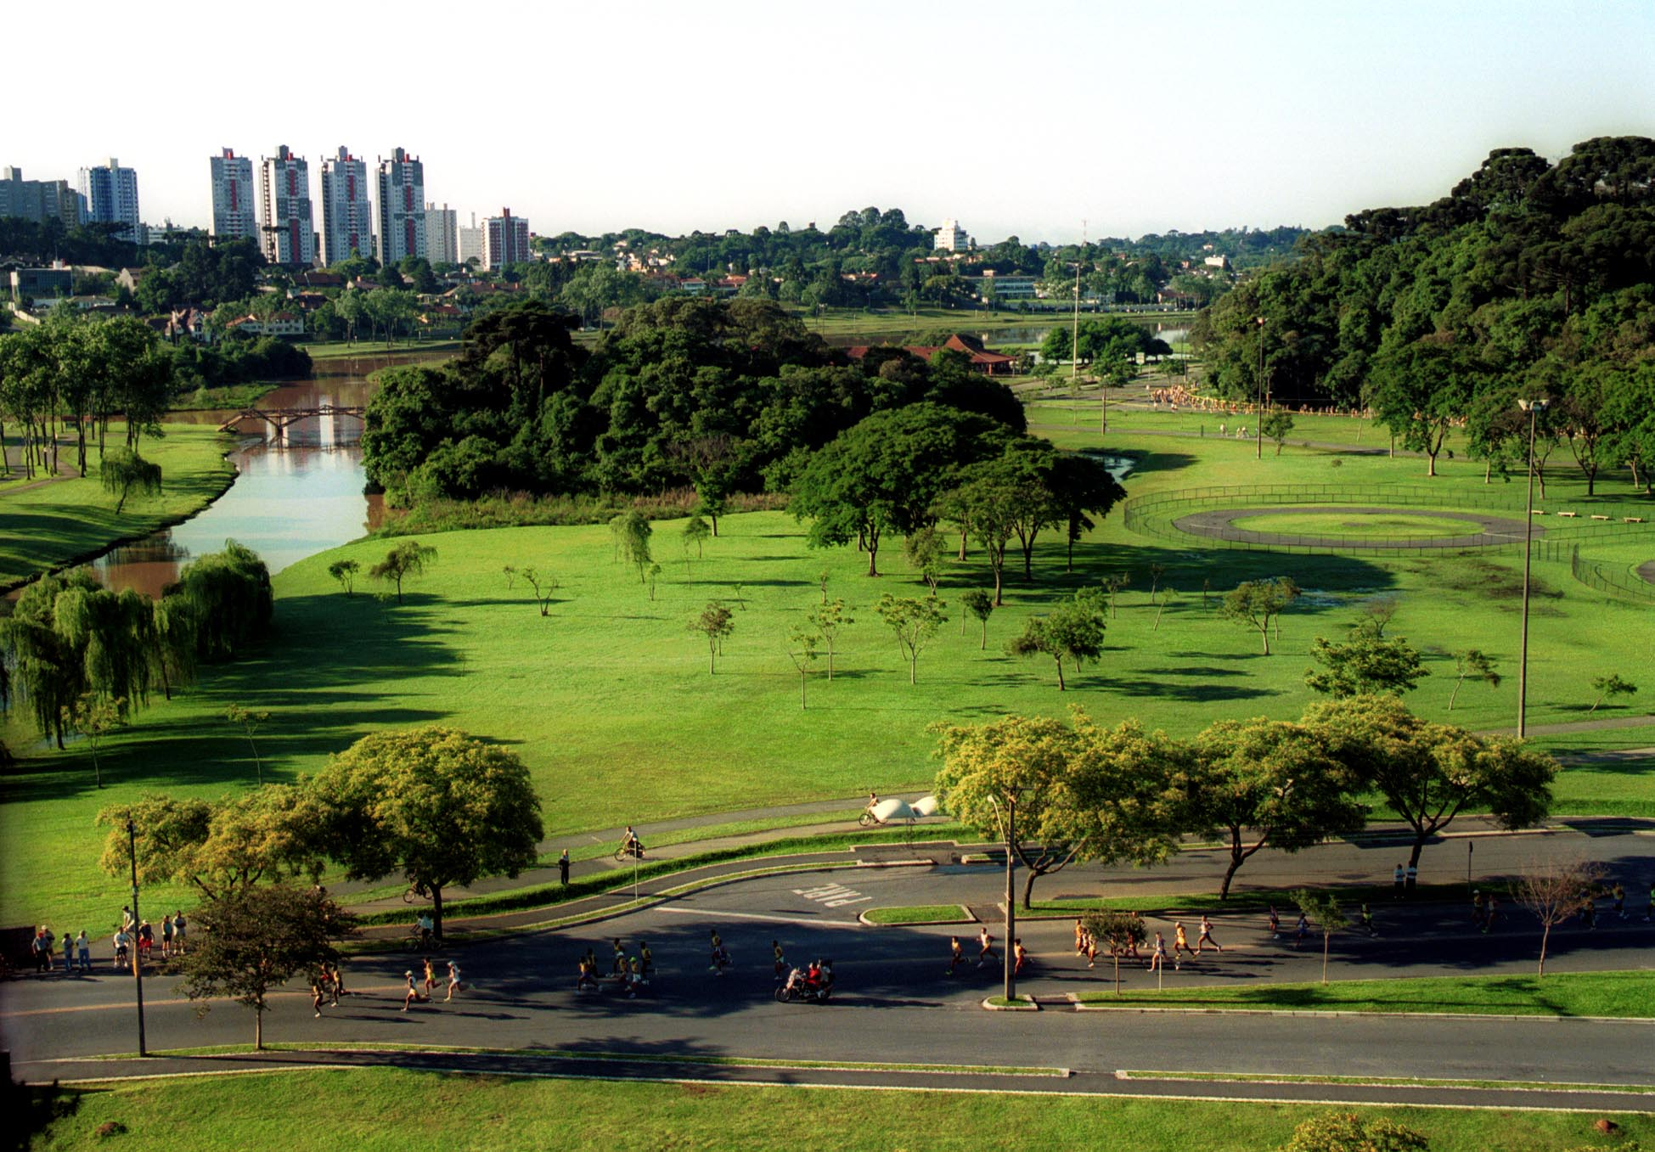

Picture

**Raul Cânovas,** one of the largest Landscape Designers in Brazil, has currently addressed in his courses and lectures on the importance of Green and Sustainability. It addresses sustainability in the urban landscape, how to tune the landscaping to the 21st century and how to make gardens that provide enjoyment, without unnecessary spending.

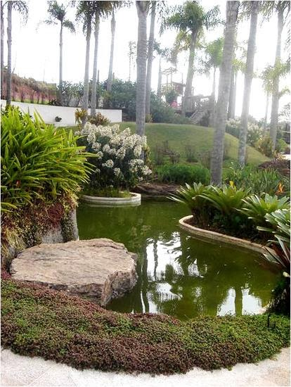

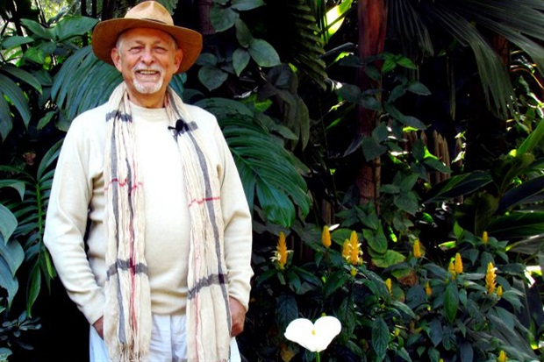

**RAUL CÂNOVAS**

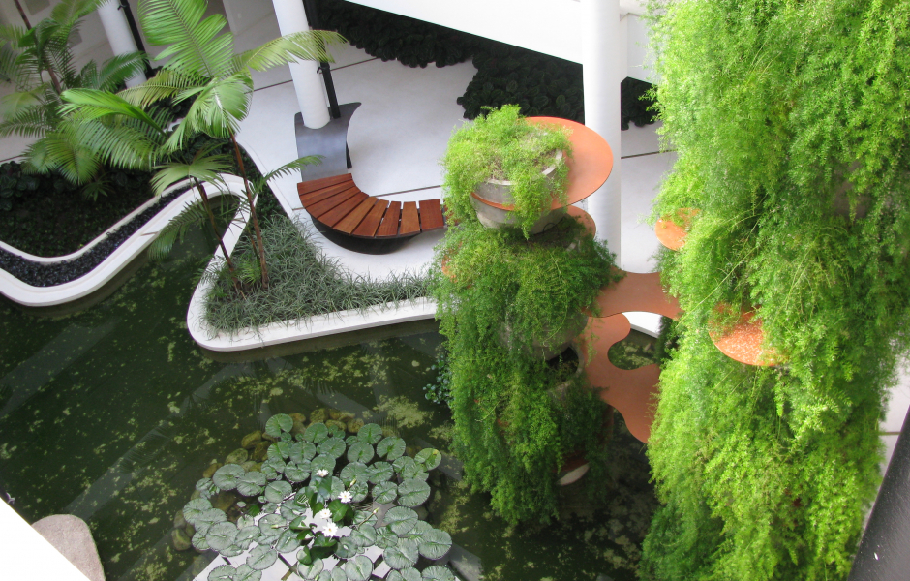



**Green World: You Healthier!**

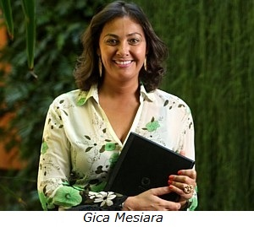

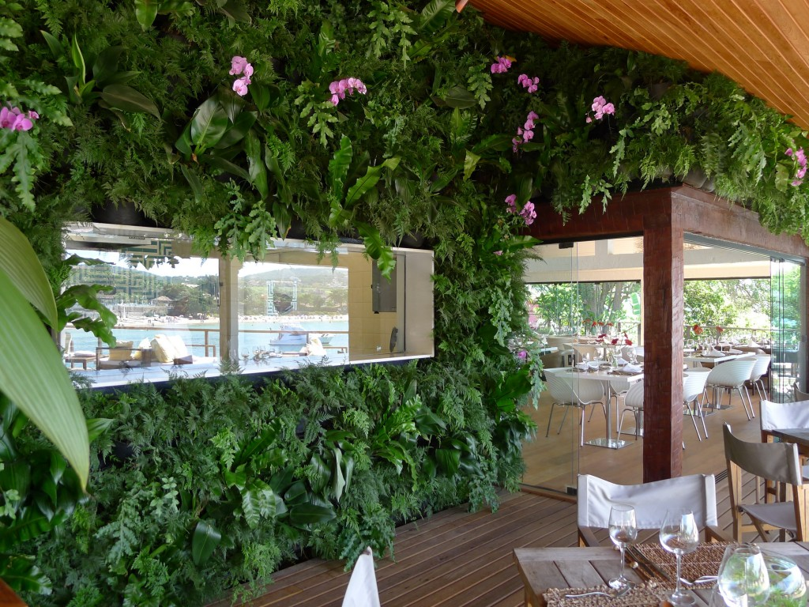

Another example is **Gica Mesiara**, who works with vertical gardens that are currently a fever in Brazil and especially in large cities where spaces become more and more limited. When one thinks of creating a garden, it is almost inevitable to think of verticality.

"I decided to turn the walls into gardens. I thought of doing this in a practical, aesthetic, modern way so that plants would be valued and exhibited. "

