PRESS RELEASE

1st December 2014
Jiangsu Province awarded AIPH Prize for best garden at Qingdao International Horticultural Exposition
The International Association of Horticultural Producers (AIPH) has awarded its prize for the best garden at the Qingdao International Horticultural Exposition 2014 to the Forest Service of Jiangsu Province in China.
Commenting on the winner, former AIPH Marketing Committee Chairman and Chairman of the International Grand Jury, Mr Shinya Wada, said “Of all the 66 gardens that we judged at the Qingdao expo the Jiangsu Province garden stood out as the best. The garden included beautiful vistas and scenes that accurately represent the landscape and culture of the province. The plants were of very high quality, maintenance was excellent and the design was masterful. I would really like to congratulate the Forest Service of Jiangsu Province for their great achievement.”
The AIPH approved (A2/B1 category) international exhibition closed on 25th October 2014 having been open for six months. Over four million visitors enjoyed the 241 hectares of gardens, pavilions and exhibitions. 109,000 trees and shrubs were planted on the site and there were over 800 species of plants displayed within the fabulous Botanical Pavilion. Over 2,500 exhibits were entered into the indoor flower competitions.
Commenting on the gardens AIPH Secretary General, Tim Briercliffe said “It was good to see both provincial and international participation. There were 37 international gardens from 35 different countries giving visitors an insight into different horticultural traditions.”
The expo also used innovative environmental and sustainable technologies, including air and soil source heat pumps, solar energy and efficient rainwater collection and re-use systems.
AIPH President, Vic Krahn, presented the AIPH Award and trophy to Jiangsu Province during the Closing Ceremony of the expo where he also gave a speech praising the work of the Expo organising committee in delivering such an inspirational exhibition. He pointed out that Qingdao had set an example for the world in highlighting the important link between plants, nature and people so critical for the sustainability of society and the environment.
Contacts
Tim Briercliffe, AIPH Secretary General
Email: sg@aiph.org Tel: +44 (0) 118 9308956 Mobile: +44 (0) 7885 750324
Website: www.aiph.org
Follow AIPH on Twitter @AIPHglobal
Notes for Editors:
International Association of Horticultural Producers (AIPH)
AIPH is a co-ordinating body representing horticultural producers' organisations all over the world. It was set up in Switzerland in 1948 to stimulate the international marketing of flowers, plants and landscaping services. Currently membership consists of 27 organisations from 20 countries and regions. AIPH is an international non-profit association based in the UK and registered in Brussels. For further details visit www.aiph.org.
AIPH is the body with authority to approve international horticultural exhibitions. The next AIPH-approved exhibitions will take place in Antalya, Turkey and Tangshan, China from April 2016. For details of all approved exhibitions over the coming years visit www.aiph.org.
For international horticultural exhibitions in China AIPH works closely with its member the China Flower Association.

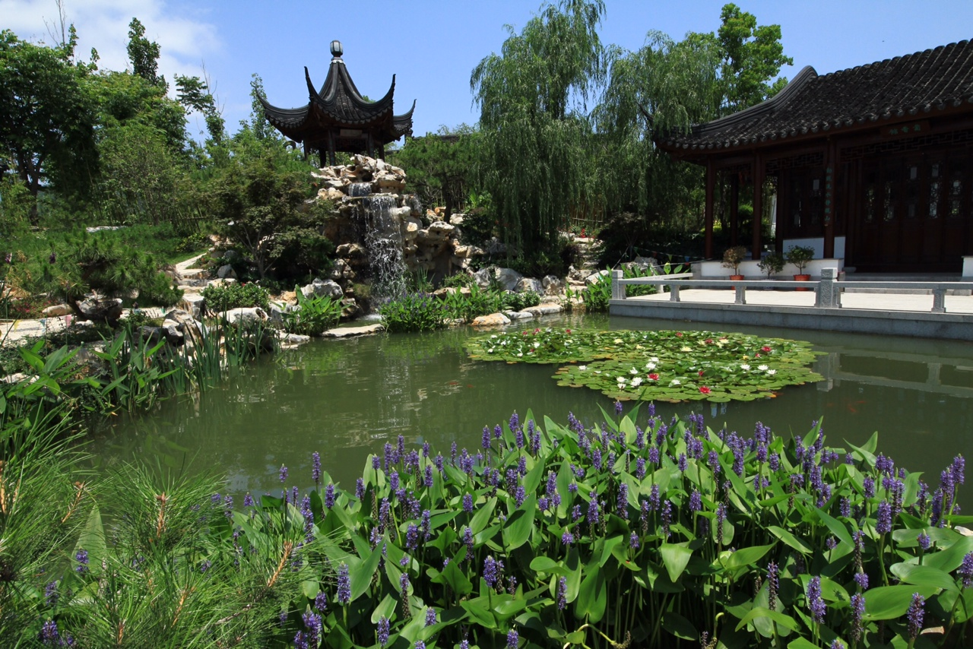
Garden of Jiangsu Province

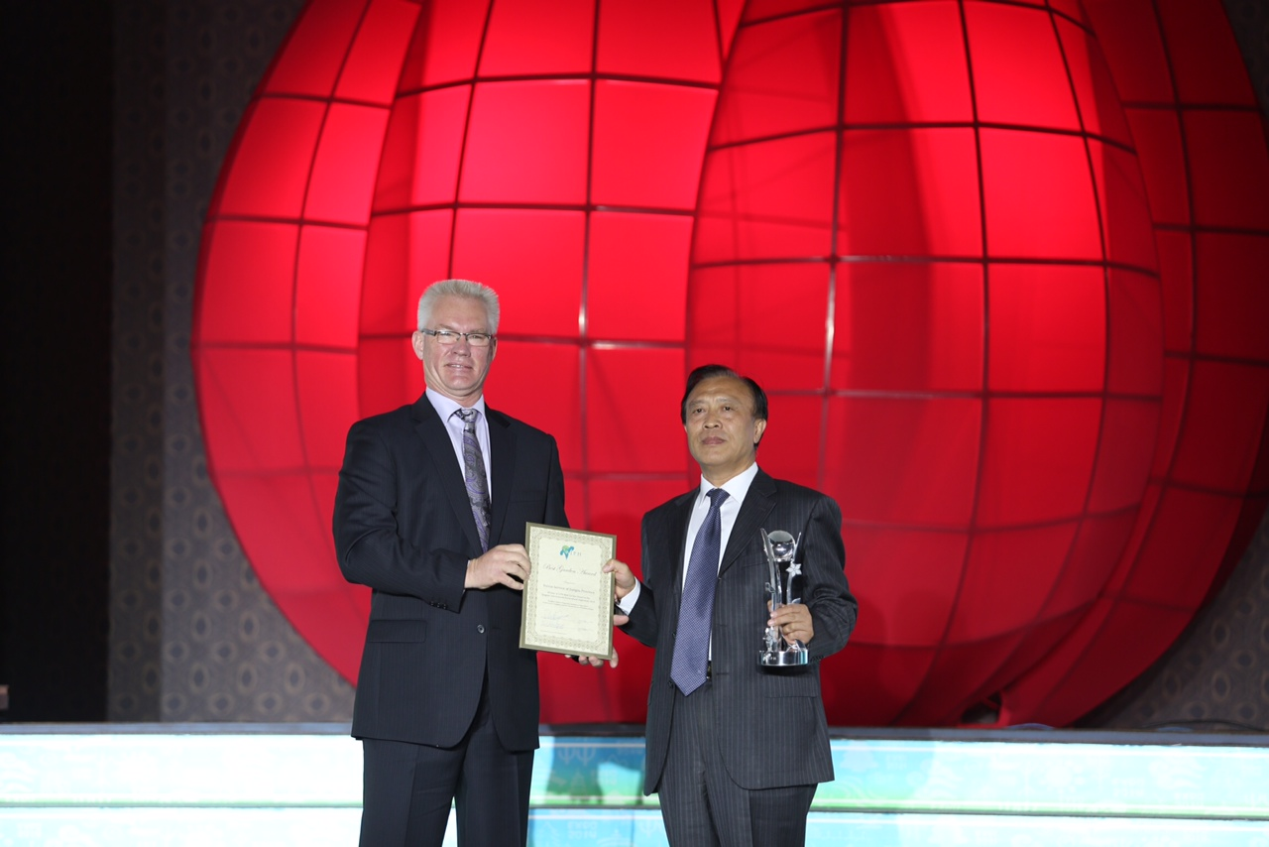
AIPH President Vic Krahn presented the AIPH Award and trophy to Jiangsu Province

